**5. Map Projection**

# What is a Map Projection?

A map projection refers to any of the numerous techniques employed in cartography to depict the three-dimensional surface of the Earth or other spherical objects on a two-dimensional plane.

While these map projection methods often involve mathematical calculations, some also rely on graphical approaches.

## **Using a globe versus a map**

A globes, which is three-dimensional, remains the sole means of depicting the Earth without introducing distortions in shape, area, distance, or scale. With their accurate metric properties, globes can effectively display spatial relationships on the Earth’s surface.

Globes present certain drawbacks, such as the challenge of creating large-scale maps, difficulties in taking measurements, the inability to view the entire world simultaneously, and the inconvenience of handling and transporting a [globe as opposed to a foldable map](https://www.gislounge.com/crumpled-maps-and-backward-globes/).

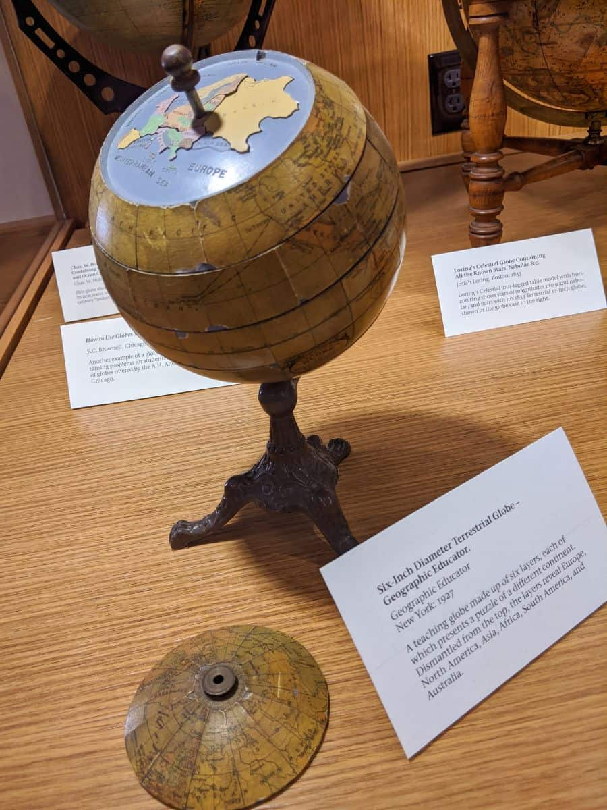

A six-inch tall teaching globe from the 1960s from the David Rumsey Map Center, Stanford University. Photo: Caitlin Dempsey.

Flat maps, why are two-dimensional, inherently come with the drawback of distorting one or more map properties, making it more challenging to accurately represent spatial relationships between objects. Nevertheless, flat maps offer numerous advantages; creating large or even medium-scale globes is impractical, measurements on flat maps are easier, they are convenient to carry, and the entire world can be viewed at once.

Bottom of Form

Only a globe can maintain a consistent scale across its entire surface, whereas the [map scale](https://www.gislounge.com/understanding-scale/) on flat maps varies from point to point and may also differ in various directions from a single point, as seen in Azimuthal maps.

## **Developable surfaces**

Developable surfaces in map projections refer to simple geometric shapes, such as cylinders, cones, or flat planes, onto which the Earth’s curved surface can be “unfolded” or “projected.”

These surfaces help cartographers create two-dimensional maps from the three-dimensional Earth while minimizing distortion in specific properties like area, shape, distance, or direction.

## **Map projection distortions**

Cartographers employ different types of map projections depending on the purpose of the map and the area being represented. These projections, while useful, inherently introduce distortions in at least one of the following properties: area, shape, direction, distance, and scale.

Map projections inherently distort one or more of the following:

1. Area-preserving projection – Also known as equal area or equivalent projection
2. Shape-preserving projection – Referred to as conformal or orthomorphic
3. Direction-preserving projection – Includes conformal, orthomorphic, and azimuthal projections (only from the central point)
4. Distance-preserving projection – Known as equidistant, which displays the accurate distance between one or two points and all other points

Creating a map projection that simultaneously preserves both area and shape is impossible.

## **Map projection categories**

Map projections are generally classified into several categories based on their properties and the surfaces they are projected onto.

**The main categories of map projections are:**

1. **Cylindrical Projections**: These projections are created by wrapping a cylinder around the Earth and projecting its features onto the cylindrical surface. Examples include the Mercator, Transverse Mercator, and Miller Cylindrical projections.
2. **Conic Projections**: In this category, a cone is placed over the Earth, and the features are projected onto the conical surface. Common conic projections are the Lambert Conformal Conic and Albers Equal-Area Conic projections.
3. **Azimuthal Projections**: Also known as planar or zenithal projections, these projections use a flat plane that touches the Earth at a single point. The Earth’s features are projected onto the plane. Examples of azimuthal projections include the Azimuthal Equidistant, Stereographic, and Orthographic projections.
4. **Pseudo cylindrical Projections**: These projections resemble cylindrical projections but use curved lines instead of straight lines for meridians and parallels. Some popular pseudocylindrical projections are the Sinusoidal, Mollweide, and Goode Homolosine projections.

**Map projections can also be categorized based on the properties they preserve:**

1. **Equal-area (equivalent) projections**: These projections maintain the correct proportions of areas, such as the Albers Equal-Area Conic and Mollweide projections.
2. **Conformal (orthomorphic) projections**: These projections preserve local angles and shapes, such as the Mercator and Lambert Conformal Conic projections.
3. **Equidistant projections:** These projections preserve true distances from one or two points to all other points, such as the Azimuthal Equidistant projection.
4. **Azimuthal projections:** These projections preserve directions from a central point, which includes some conformal, orthomorphic, and azimuthal projections.
5. **Compromise projections:** These projections seek to balance the various distortions inherent in map projections, such as the Robinson and Winkel Tripel projections.

It is important to note that no map projection can preserve all properties perfectly, as each type involves some degree of compromise or distortion.

## **Cylindrical Projections**

### **List of cylindrical map projections**

* Mercator
* Transverse Mercator
* Oblique Mercator
* Cylindrical Equal-Area
* Miller Cylindrical
* Equidistant Cylindrical
* Cassini

**Questions**

1. What is map projection? Explain the importance of map projection.
2. What are the main categories of map projections?
3. Describe the four/five types of map projections by the properties they preserve.